**Faculty of Computing & Information Technology**



Title: **“PETx” FYP Documentation**

Group ID: **BSEF19-17**

|  |  |  |
| --- | --- | --- |
| **Sr #.** | **Roll Number** | **Student Name** |
| 1 | BSEF19M031 | Ata Ul Mohsin |
| 2 | **BSEF19M033** | **Hassan Ahmad Sarfraz (Lead)** |
| 3 | BSEF19M037 | Muhammad Saad |
| 4 | BSEF19M047 | Muhammad Saleh Butt |

Project Supervisor: Ma’am **Natalia Chaudhary**

Date of Submission:

Jun 15, 2023

Table of Contents

|  |  |  |
| --- | --- | --- |
| **Serial Number** | **Document** | **Page Number** |
| 1 | FYP Registration Form | 3 |
| 2 | PETx Proposal | 4 |
| 3 | Deliverable One | 14 |
| 4 | Deliverable Two | 38 |

Page 2 of 2

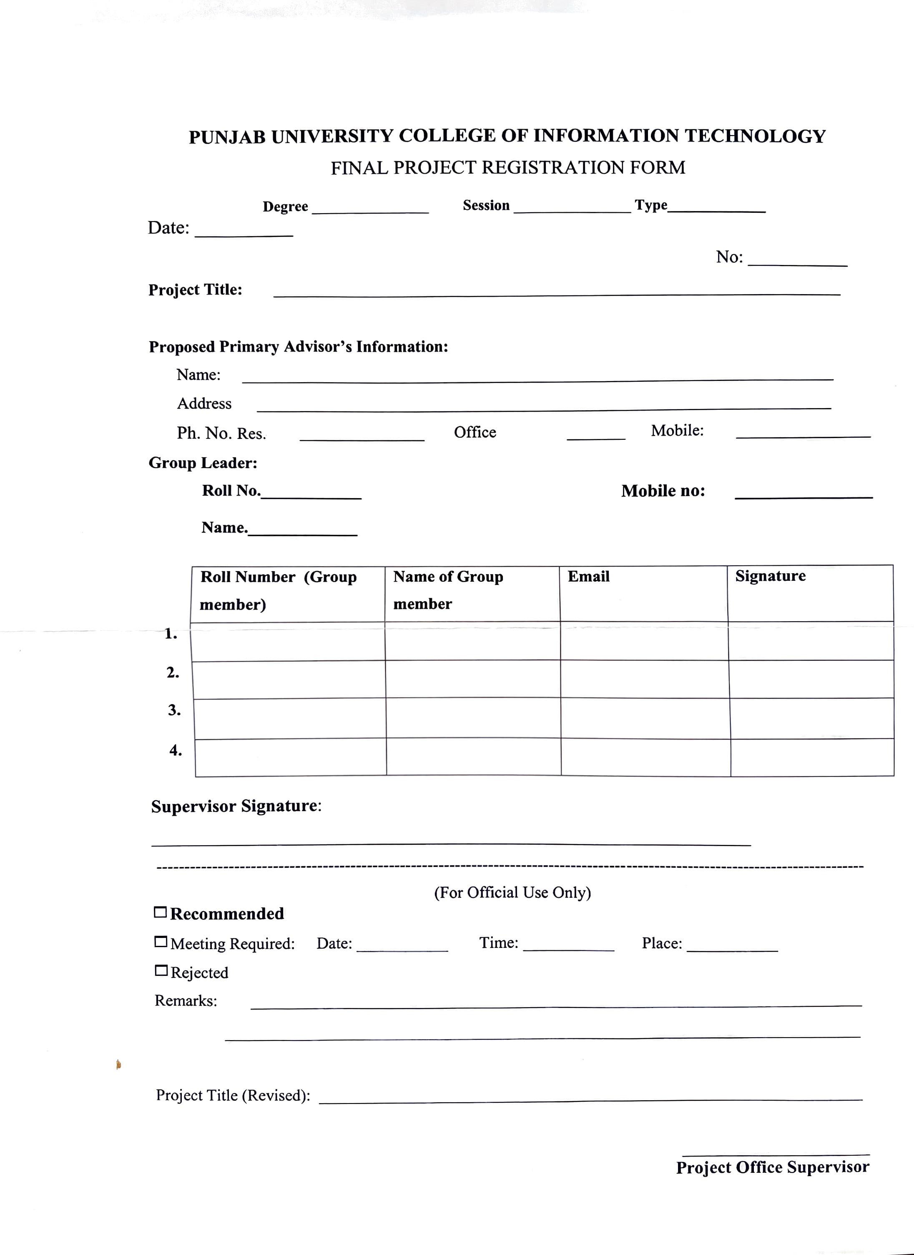

7th Nov, 22

SE

F19-M

Research

PETx

**PUCIT, OLD CAMPUS, KATCHERY ROAD, UNIVERSOTY OF THE PUNJAB, LAHORE.**

PETx

NATALIA CHAUDHARY

**- - 03224118071**

BSEF19M033

03039636478

HASSAN AHMAD SARFRAZ

**ATA UL MOHSIN**

BSEF19M031

[BSEF19M031@PUCIT.EDU.PK](mailto:BSEF19M031@PUCIT.EDU.PK)

**Muhammad Saad M SALEH BUTT HASSAN AHMAD**

BSEF19M047

BSEF19M037

BSEF19M033

[BSEF19M033@PUCIT.EDU.PK](mailto:BSEF19M033@PUCIT.EDU.PK)

[BSEF19M047@PUCIT.EDU.PK](mailto:BSEF19M047@PUCIT.EDU.PK)

[BSEF19M037@PUCIT.EDU.PK](mailto:BSEF19M037@PUCIT.EDU.PK)

#### PUCIT

Punjab University College of Information Technology



#### Final Project Proposal Version 1.0



#### TABLE OF CONTENTS

#### Final Project Proposal 3

1. Introduction 3
   1. Project Title 3
   2. Project Overview Statement 3
   3. Project Overview Statement 4
   4. Project Goals & Objectives 5
   5. High-level system components 5
   6. List of optional functional units 5
   7. Exclusions 5
   8. Application Architecture 6
   9. Gantt chart 7
   10. Hardware and Software Specification 9
   11. Tools and technologies used with reasoning 9

Final Project Proposal



##### Introduction

With the fast-paced and everyday developing world, we have excelled in almost every field related to humans. Everyone is pushing the limits to facilitate humanity. In this race of serving humanity, we have, somehow, overlooked animals and their facilities. Being human poses some responsibilities to us that also includes a duty to protect the living creatures around us. We don't even have sufficient time for our pets, from our busy and social life. This project is specially chosen to provide a simple and easy approach to avail pet-related services to pet owners so that their pets can get what they need at the right time.

##### Project Title

PETx

##### Project Overview Statement

As the name suggests, the project revolves around animal care and services related to them. Since everyone is so engaged in their lives, no one finds enough time to research their pet, which doctor is better, and where to find the best quality pet products. In case, some animal is ever struck in a do-or-die situation, no one knows how to help the poor soul. Thus keeping all this in mind, PETx will provide all these services with ease so that pet owners can serve their pets with peace of mind.

#### Project Overview Statement

|  |  |  |  |
| --- | --- | --- | --- |
| Name | Registration # | Email Address | Signature |
| ATA UL MOHSIN | BSEF19M031 | [bsef19m031@pucit.edu.pk](mailto:bsef19m031@pucit.edu.pk) | *AUMohsi>* |
| HASSAN AHMAD SARFRAZ | BSEF19M033 | [bsef19m033@pucit.edu.pk](mailto:bsef19m033@pucit.edu.pk) | *Hassa>Ah at* |
| MUHAMMAD  SAAD | BSEF19M037 | [bsef19m037@pucit.edu.pk](mailto:bsef19m037@pucit.edu.pk) | *SaadA jad* |
| MUHAMMAD  SALEH BUTT | BSEF19M047 | [bsef19m047@pucit.edu.pk](mailto:bsef19m047@pucit.edu.pk) | *M aleL* |

|  |  |
| --- | --- |
| Sr.# |  |
| 1 | Develop a rescue system for pets |
| 2 | Community building through a social interaction corner for pet owners. |
| 3 | Add online veterinary appointment system |
| 4 | Add blockchain-based payment systems |

|  |
| --- |
| Project Title:  **PETx** |
| Group Leader: **Hassan Ahmad Sarfraz** |
| Project Members: |
| **Project Goal:**  To create a safe space for pets in the community by providing their owners with multiple pet-related services on a single platform. Also encouraging users to use his crypto for payments. |
| **Objectives:** |
| **Project Success criteria:**  Develop an all-in-one place for pet-related services so that pet owners can find the best for their pets with minimum effort on a single platform. |
| **Assumptions, Risks, and Obstacles:**   * It is assumed that there are some service providers working already in the market. We will be developing a platform to onboard them and unite their services on a single web app. * There is a risk that providers do not provide the promised service quality which can result in a dent in our reputation and loss of customers as well. * Limited tech knowledge in hand. |
| Organization Address (if any): |
| Type of project: Research |
| Target End users: Pet Owners, Pet Rescuers, Doctors |
| Development Technology: Object Oriented |
| Platform: Web-based |
| Suggested Project Supervisor: **Natalia Chaudhary** |
| Approved By: |
| Date: Nov 4, 2022 |

##### Project Goals & Objectives

#### Goals:

* + 1. To help pet owners take the best care of their pets.
    2. To make it easy for people to adopt pets by providing ease in services.
    3. To reduce the number of animal deaths by providing immediate first aid services.
    4. To help people show affection to injured animals by using our rescue service.
    5. To make revenue by making it easy for humans to treat animals with kindness.

#### Objectives:

To achieve the above goals we are determined to:

1. Develop a rescue system for pets
2. Add online veterinary appointment system
3. Community building through a social interaction corner for pet owners.
4. Add blockchain-based payment systems

##### High-level system components

* + 1. Login / SignUp: Leads the user to Landing Page
    2. Rescue Service: No login required, Immediate contact to rescue team
    3. Appointment Section: Browse through doctors list, see reviews and choose from available appointment times.
    4. Blog page: Users can share their insights, findings, research, experiences, or other information with each other.
    5. Payment: Blockchain-based secure payment system

##### List of optional functional units

* + 1. Online store: Where users can buy all kinds of pet accessories, food, and medicines.
    2. Shelter Home: Where you can submit some stray / orphan animals, adopt a pet, or might abandon your pet as well.

##### Exclusions

Functionalities: Due to limited time, we might not be able to practically implement optional functionalities.

Performance: Due to a very limited budget, we would not be able to buy subscriptions for an excellent host thus performance can be compromised.

Traffic: We will also face traffic limitations that might not be able to handle a large number of online users at once.

Domain name: Domain name has a key role in attracting an audience. Due the limited budget, we would be buying any popular domain like .com etc, instead, we will be any less attractive one that would fit in our budget.

##### Application Architecture

We will be using Three-Tier architecture for this project. These 3 layers will be as

* + 1. Frontend Tier
    2. Application Tier
    3. Database Tier

Frontend will be handled using HTML5, CSS3, ES6, and ReactJS. The application tier will be implemented using NodeJS and ExpressJS. While the last layer of the database will be implemented using MongoDB.

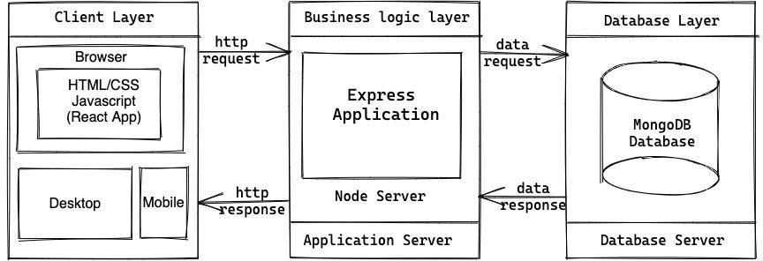

##### Gantt chart

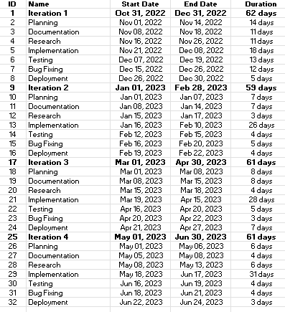

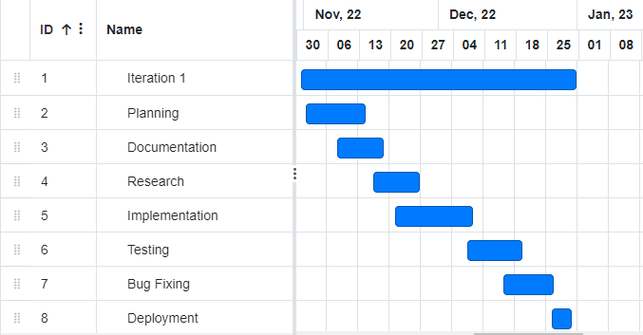

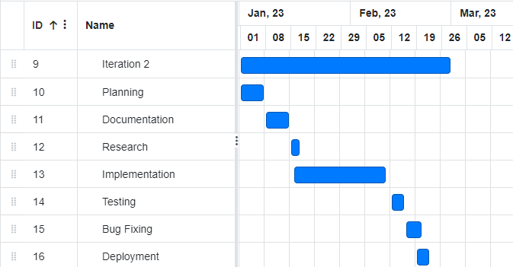

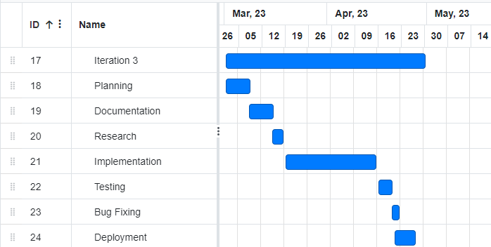

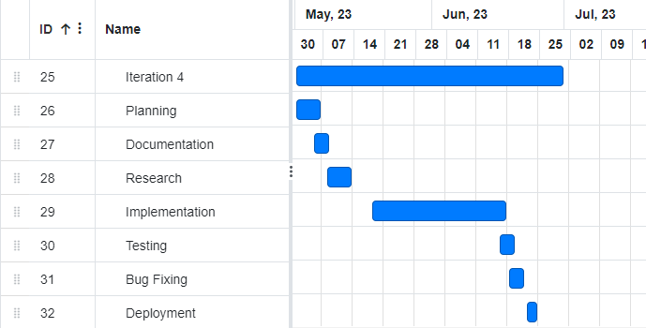

##### Hardware and Software Specification

#### Client-Side Hardware Requirements:

Laptop or Desktop or Mobile Device

#### Client-Side Software Requirements:

Browsers that can support HTML 5

##### Tools and technologies used with reasoning

|  |  |
| --- | --- |
| **Tools** | **Reason** |
| VS Code | Used as IDE for front-end development. It is lightweight, extensible, free, open source and cross-platform |
| GitHub and Git | Used for team collaboration. Git is a version control system that lets you manage and keep track of the source history. GitHub is a cloud-based hosting service that lets you manage Git repositories. |
| Google Docs | Used for documentation. It helps to make professional-quality documents. |

|  |  |
| --- | --- |
| **Technology** | **Reason** |
| **ReactJS** | It's used for building interactive user interfaces and web applications quickly and efficiently with significantly less code than you would with vanilla JavaScript. |
| **NodeJS** | Node. js is commonly used to develop real-time applications, also known as RTAs. Its asynchronous, event-driven nature, allows it to handle heavy input-output operations, which makes it much easier for Node. js developers to achieve the level of performance users have come to expect from modern real-time applications. |
| **ExpressJS** | Express is a node js web application framework that provides broad features for building web and mobile applications. It is used to build a single page, multipage, and hybrid web application. It's a layer built on top of the Node js that helps manage servers and routes. |
| **MongoDB** | is an open-source NoSQL database management program. NoSQL is used as an alternative to traditional relational databases. NoSQL databases are quite useful for working with large sets of distributed data. MongoDB is a tool that can manage document-oriented information, and store or retrieve information. |

**Faculty of Computing & Information Technology**



Title: **PETx** Deliverable One

|  |  |  |
| --- | --- | --- |
| **Sr #.** | **Roll Number** | **Student Name** |
| 1 | BSEF19M031 | Ata Ul Mohsin |
| 2 | **BSEF19M033** | **Hassan Ahmad Sarfraz (Lead)** |
| 3 | BSEF19M037 | Muhammad Saad |
| 4 | BSEF19M047 | Muhammad Saleh Butt |

Course Name: Final Year Project

Project Supervisor: Ma’am Natalia Chaudhry Date of Submission:

Nov 21, 2022

#### TABLE OF CONTENTS

Introduction 4

Project/Product Feasibility Report 4

Technical Feasibility 4

Operational Feasibility 4

Economic Feasibility 5

Schedule Feasibility 5

Specification Feasibility 5

Information Feasibility 5

Motivational Feasibility 5

Legal & Ethical Feasibility 6

Project/Product Scope 6

Project/Product Costing 6

Project Cost Estimation By Function Point Analysis 6

Project Cost Estimation by using COCOMO’81 (Constructive Cost Model) 7

CPM - Critical Path Method 7

Gantt chart 9

Iteration One 10

Iteration Two 11

Iteration Three 11

Iteration Four 12

Introduction to Team members and their skill set 12

Tools and Technology with reasoning 13

Vision 14

-- In the loving memory of Laika 14

Elaborated View 14

Risk List 15

Systems Specifications 15

Introduction 15

Existing System 15

Phases of the System Development 16

Phase I 16

Phase II 16

Phase III 16

Organizational Chart 16

Summary of Requirements (Initial Requirements) 17

Rescue System 17

Veterinary Doctor Appointment System 17

Social Feed 18

Identifying External Entities and Actors 18

Context Level Data Flow Diagram 18

Capture "shall" Statements 19

Allocate Requirements 19

Prioritize Requirements 20

Requirements Trace-ability Matrix 21

High Level Use Case Diagram 22

Business Level 22

Analysis Level 24

# Introduction

PETx will be all in one platform for services related to pets. We aim to facilitate pet owners by creating an online veterinary appointment system, rescue system, and social community specifically designed for pet owners. Apart from that, it will serve as a social awareness platform about pets for the general public and application visitors.

# Project/Product Feasibility Report

To make PETx, we have commands on MongoDB, ReactJS, NodeJS, and ExpressJS to design and function websites while also having a database connected to them. For this project we will use a desktop having either Windows or Linux, CPU 2.0 GHz or more, RAM 8GB or more, having tools such as VS Code, Git, GitHub, etc. Our team members are capable of doing frontend, and backend as well as connecting databases, thus the “PETx” can be developed within a given time.

There are many types of feasibilities:

* Technical
* Operational
* Economic
* Schedule
* Specification
* Information
* Motivational
* Legal and Ethical

## Technical Feasibility

This project requires command on development of frontend, backend, and database. For this purpose, we will use MongoDB, ReactJS, NodeJS, and ExpressJS. Our team does possess the ability to create this project, thus the project can be developed. For development purposes, Windows or LINUX, CPU 2.0 GHz or more, and RAM 8GB will be needed which will already have, so the development of this project is possible within the given time.

## Operational Feasibility

With respect to the operational feasibility of the project, we aim to use the system for the following purposes. It is believed that they are important for the user base.

* Rapid Emergency Services for Pets
* Easy approach to veterinary doctors for pet owners
* Social interaction for Pet owners
* More societal awareness about Pets
* Feel of satisfaction upon using the services of PETx

Development of this project will benefit many people who have pets yet are unable to find a one-stop shop for their pets. Upon sharing this idea with people around us having pets we get a positive response thus we think this project has a high probability of success.

## Economic Feasibility

The project cost is not very high. The required softwares is either open source or we are using student subscriptions. For the hardware costs, we already have the required and recommended machines for development. Irrespective of the financial benefits we gain from the project, input resources will be low and hence it is a win-win situation in either case.

## Schedule Feasibility

For schedule feasibility, we have a dedicated team of four members ready to work 15 hours per week for this project. So, we believe that the project milestones will be achieved within the given time frame.

## Specification Feasibility

Requirements for this project have been analyzed, refined, and specified with mutual understanding of group members (stakeholders of the project). So, requirements are all set for the next phase which is implementation. The project scope has also been discussed and finalized. Some of the requirements have been labeled as options for the first year of the project.

## Information Feasibility

All the information regarding the pet will be uploaded by the pet owner which will have a verified account. Furthermore, if an admin thinks the information uploaded by the user is false, he will be able to delete it. In the case of the newsfeed, the same policy of admin controls will be applicable. The non-admin users will be able to report content.

## Motivational Feasibility

The team responsible for the project is ready and energized to start working on the project. We as a team are on the same and with the same mindset to create an impact in the community and that is why we have started this project.

## Legal & Ethical Feasibility

Information and data hiding of stakeholders (patients, doctors, and volunteers) is solely the responsibility of the development team and we are taking care of using various techniques. That is the only legal responsibility and we are bound to secure the system from illegal usage.

# Project/Product Scope

The main aim of the project revolves around the rescue of pets in times of distress. This involves communication between doctors and pet owners. The product will also facilitate veterinary doctors to work from home instead of being bound to specific locations. The project will also cover online payments to doctors and storing the information of pets in blockchain-based system

Project scope has been defined, validated, and specified. With the passage of time, we aim to extend the scope or descope in the coming iterations and sprints.

# Project/Product Costing

## Project Cost Estimation By Function Point Analysis

Function Point Metric Calculated using: [https://w3.cs.jmu.edu/bernstdh/web/common/webapps/oop/fpcalculator/FunctionPointC](https://w3.cs.jmu.edu/bernstdh/web/common/webapps/oop/fpcalculator/FunctionPointCalculator.html) [alculator.html](https://w3.cs.jmu.edu/bernstdh/web/common/webapps/oop/fpcalculator/FunctionPointCalculator.html)

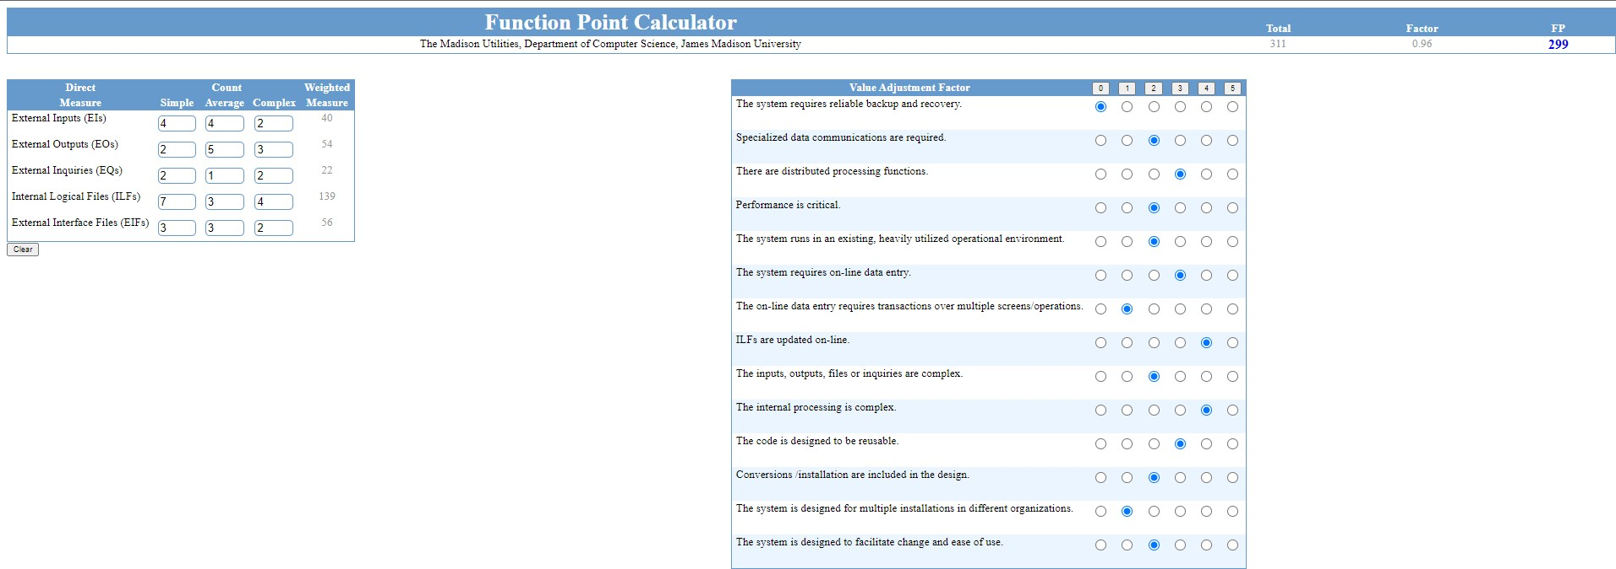

#### Calculate Function Point:

FP est. = 299 p-m

#### For our project:

#### Assuming:

1 month = 22 working days, per person

Labour Rate =30000 Rs/pm (per day: 1363.63 Rs) Average productivity = 15 FP/month (per day: 0.58 FP)

**Cost per FP= Cost/FP=Labor Rate/Productivity** Cost/FP = Labour rate / productivity parameter Cost/FP= 1363.63/0.58

Cost/FP= 2350 Rs/FP

#### Total Project Cost = FP estimation * (Cost/FP)

Total Project Cost = 299 * 2350 Total Project Cost = 702,650 Rs

#### Effort=Total cost/Labor rate per p-m

#### Total estimation effort =FP estimation / productivity parameter

Total estimation effort = 299/15

Total estimation effort =19.93 pm. (19.93 * 22 = 430 days)

## Project Cost Estimation by using COCOMO’81 (Constructive Cost Model)

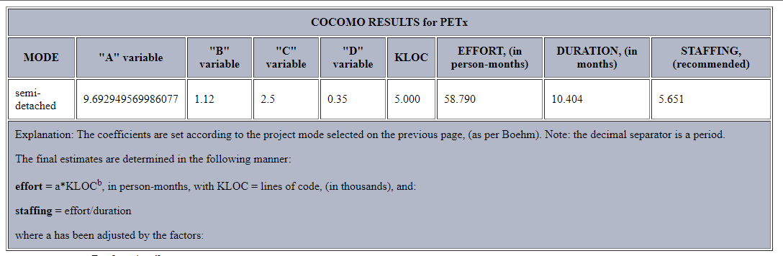<https://strs.grc.nasa.gov/repository/forms/cocomo-calculation/> <http://softwarecost.org/tools/COCOMO/>

# CPM - Critical Path Method

[Access the calculator used for this calculation](https://www.easycalculation.com/operations-research/pert-cpm-calculator.php)

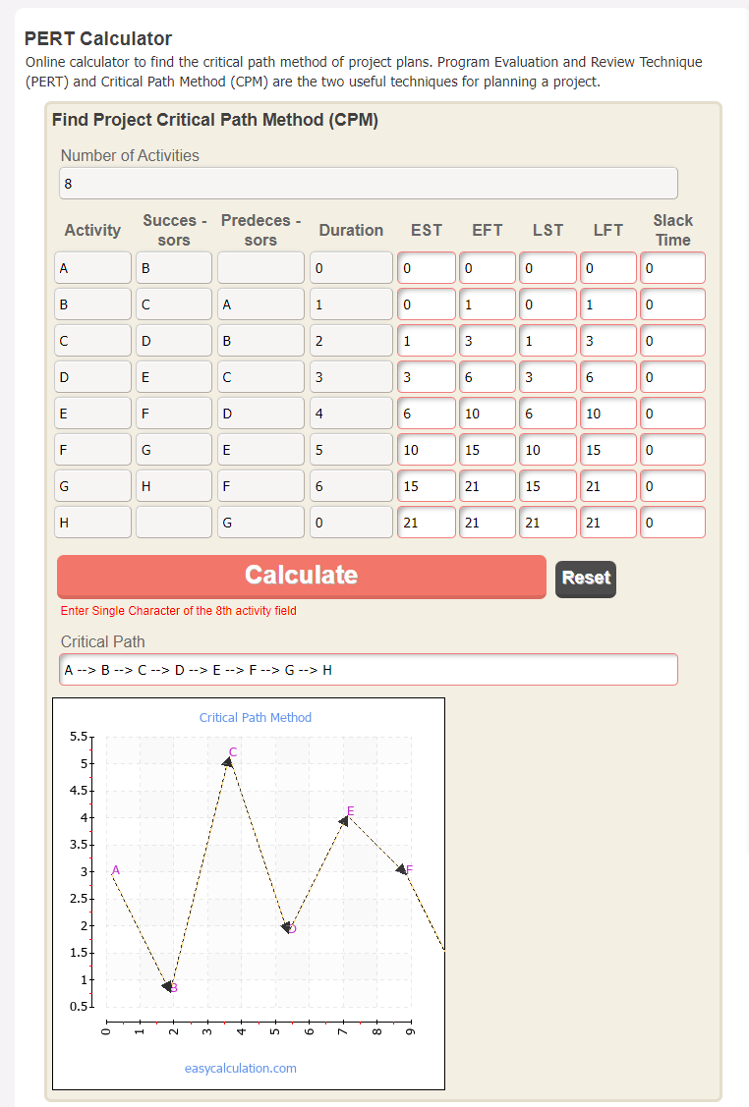

# Gantt chart



## Iteration One



## Iteration Two

## Iteration Three



## Iteration Four



# Introduction to Team members and their skill set

|  |  |  |  |
| --- | --- | --- | --- |
| **Serial No.** | **Name** | **Expertise** | **Responsibilities** |
| 1 | ATA UL MOHSIN | ReactJS, Quality Assurance | * Frontend Development of PETx * Quality Assurance of the product |
| 2 | HASSAN AHMAD SARFRAZ | MongoDB, Express | * Backend development of PETx * APIs creation and usage |
| 3 | MUHAMMAD SAAD | ReactJS, Blockchain | * Research on blockchain for PETx * Frontend development |
| 4 | MUHAMMAD SALEH BUTT | NodeJS, MongoDB | * Backend development * Database handling |

# Tools and Technology with reasoning

|  |  |
| --- | --- |
| **Tools** | **Reason** |
| VS Code | Used as IDE for front-end development. It is lightweight, extensible, free, open source and cross-platform |
| GitHub and Git | Used for team collaboration. Git is a version control system that lets you manage and keep track of the source history. GitHub is a cloud-based hosting service that lets you manage Git repositories. |
| Google Docs | Used for documentation. It helps to make professional-quality documents. |

|  |  |
| --- | --- |
| **Technology** | **Reason** |
| **ReactJS** | It's used for building interactive user interfaces and web applications quickly and efficiently with significantly less code than you would with vanilla JavaScript. |
| **NodeJS** | Node. js is commonly used to develop real-time applications, also known as RTAs. Its asynchronous, event-driven nature, allows it to handle heavy input-output operations, which makes it much easier for Node. js developers to achieve the level of performance users have come to expect from modern real-time applications. |
| **ExpressJS** | Express is a node js web application framework that provides broad features for building web and mobile applications. It is used to build a single page, multipage, and hybrid web application. It's a layer built on top of the Node js that helps manage servers and routes. |
| **MongoDB** | is an open-source NoSQL database management program. NoSQL is used as an alternative to traditional relational databases. NoSQL databases are quite useful for working with large sets of distributed data. MongoDB is a tool that can manage document-oriented information, and store or retrieve information. |

# Vision

### -- In the loving memory of Laika

An online portal where users can call rescue teams for pets or birds in times of distress and those team’s manager/administrator can send the nearest team to spot for help.

This portal will also serve as a base for online appointments with pets and veterinary doctors.

Inspiration for this project is from the first animal taken in earth orbit, a female dog named Laika. While returning back to earth, the spacecraft malfunctioned and she was dead in a few moments. Would it have been much better if some kind of rescue or ejection system was placed there? Let’s aim to help them at least in our capacity (nearby areas).

## Elaborated View

* Introduction

We want to design a system or marketplace to be more precise in which we can gather all the important and major services that a pet owner usually needs. We want to develop a platform where the pet owner need not worry about most things associated with pets. This marketplace could make the life of a pet owner easier.

* Positioning

Individual services related to pets may be available out there, but we lack a system where one can get everything almost at arm's length. Such a system does not exist with such a unique idea that makes pet keeping a lot easier and more convenient. So we are almost certain that we are going to make our own benchmark in the market and will serve the community as well.

* Stakeholder description

Our stakeholders include our sponsors that are from other domains but looking forward to working with us for their advertisement and branding.

The chief investor hit upon the idea and decided to make his dream come true. Also the companies from our domain that want to cooperate with us and provide us with their best services to entertain our end users.

* High-level goals

A marketplace where we can earn both good repute and profit by serving the pets community. Our goal is to hit the highest rank in the market by developing a system in which a pet owner can get easy access to all the things he needs for the best growth of his pet.

* User-level goals

The idea is to provide an emergency rescue team for animals in general that are trapped in a dangerous situation so that their lives may get saved.

We also want to make pet keeping hassle-free by providing our vet care services that include a general appointment with doc for consultation or an appointment with doc for some specific medical condition.

And last but not least, we will be providing our users a common place where similar pet owners could interact with each other to have guidelines from experienced ones or just share their thoughts with others.

* Product overview

A full-fledged product that will take away all the tension from the mind of pet owners by providing assistance at every step he wants. We will make pet keeping more fun and peace of mind than ever.

* Summary of features

Users can call the rescue team for emergencies. Users can consult a doctor on general concerns or can have an appointment with a specialist for having a specific issue / disease-oriented discourse. A section of the social community will also be added for the interaction of pet owners with other owners.

# Risk List

Listed from highest to lowest risk

1 means the highest risk and 6 means the lowest risk.

1. Customers/Users may change their functional/ elemental requirements.
2. Performance may not be according to the needs of the client.
3. Security and privacy may not be enough for clients.
4. Project costs may increase later.
5. We may have to modify throughout the project resulting in development side loss.
6. Development team may not meet the deadline for the project.

# Systems Specifications

## Introduction

PETx is an emergency medical service for pets which deals with basic medical prescriptions from veterinary doctors to providing volunteer service to pets in emergency situations. In Pakistan from urban to rural areas, pets and cattle are found in every town.However, the number of which is diminishing day by day due to unavailability of doctors to treat pets and lack of awareness about them.

## Existing System

* PETx system mainly deals with the following aspects:
  + Basic Medical Prescription for pets
  + Emergency Rescue service
  + NewsFeed for pet owners
* *Basic Medical Prescription for pets*
  + Deals with prescribing basic medicine to pets
* Emergency Rescue service
  + Deals with providing emergency rescue services to pets on voluntary basis
* NewsFeed for pet owners
  + To share stories about pets Facebook-like news feed will be maintained in system

## Phases of the System Development

The PETx System is divided into three phases.

### Phase I

Phase I includes the following basic architecture areas:

* Landing pages
* Simplified UI
* Database Setup

### Phase II

Phase II involves improvement of user experience. Phase II includes the following areas:

* Customized Roles
* Improved UX and UI

### Phase III

Phase III covers a complete solution for PETx. Phase III includes remaining business areas which are not developed in previous phases.

* Blockchain-based payment system
* Blockchain to be used for storing pet information

## Organizational Chart

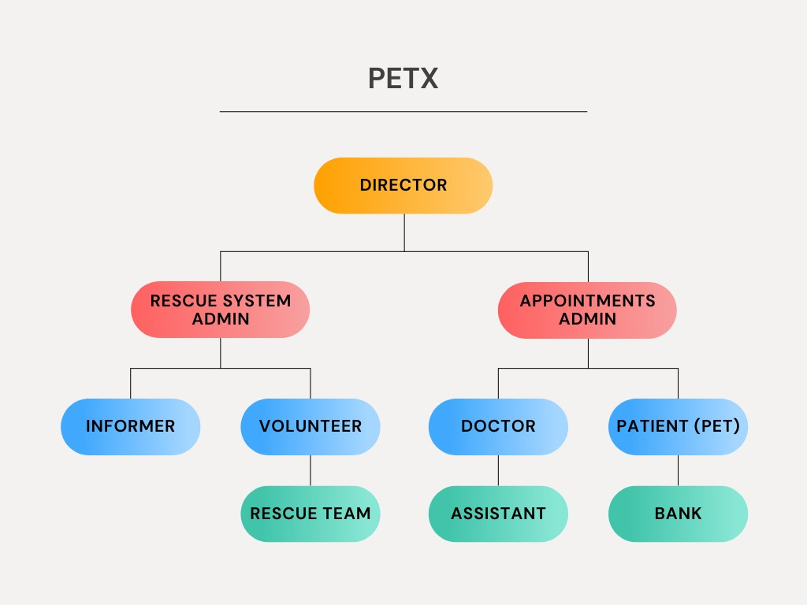

## Summary of Requirements (Initial Requirements)

An abstract is necessary at this stage to give an understanding of the initial requirements of the system. This will show what high-level requirements the proposed system must address. This abstract will act as a foundation for the future analysis of the system.

### Rescue System

Rescue system is the prime feature of our project. This module will require emergency situation information from the informer or the person who told the system about distress. This information should be in a form having location, contact number, and related information if any about the situation. Once an emergency event is initiated, it’ll alert the volunteers and nearby rescue teams to move toward the location. Here only one team will be assigned the task of rescue and that team or volunteer will complete the job. If the task is not completed by a volunteer, a team will be assigned the job then.

### Veterinary Doctor Appointment System

The logged-in customer or pet owner will visit the page of available doctors and will select a doctor according to his requirements. Then, he’ll be asked to schedule an appointment from the

available time slots of a doctor. If he selects the time, the doctor will be notified about the scheduled appointment and then the person will move to the payment page which will be the banking site for the transaction.

From the doctor's side, he’ll be able to see scheduled appointments from his side and will be able to change availability hours and fees.

### Social Feed

This will serve as a community for pet owners. They’ll be able to see posts of other users in their feed and like, and comment on them. These posts will be focused on pets only just like a Facebook group. Our first priority in this regard will be to integrate this module with Facebook APIs. Otherwise, we shall develop our own social media system.

## Identifying External Entities and Actors

#### Primary Actors

* + Veterinary Doctors
  + Informer
  + Customer

#### Secondary Actors

* + Rescue Team
  + Bank

## Context Level Data Flow Diagram

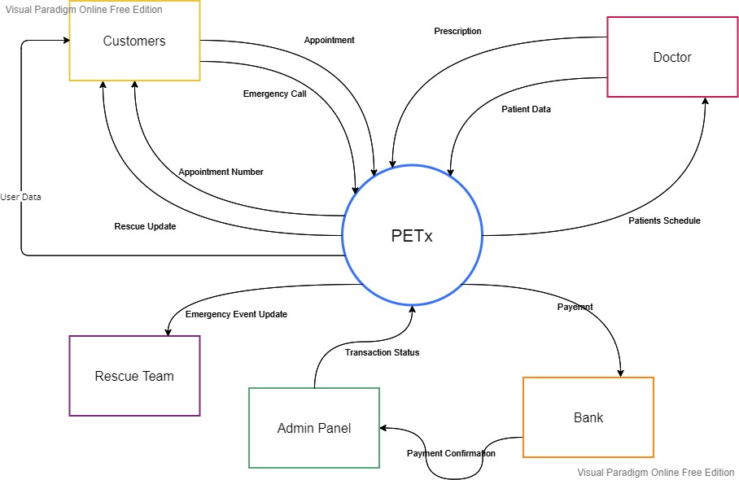

## Capture "shall" Statements

* Call for emergency pet rescue
  + The system shall be able to contact animal rescuers for help in times of emergency.
* Consultancy
  + The system shall be capable of online appointments with veterinary doctors.
  + The system shall be able to remind registered users of regular checkups of their pets via email or SMS.
* Interaction with similar pet owners
  + There shall be able to handle a community where registered users can interact with other users via posts or messages.
* FAQs/ Infopedia
  + The system will consist of an FAQ list for common questions.
* Membership or Special Discounts
  + The system shall be able to offer special discounts on different occasions.

## Allocate Requirements

|  |  |  |
| --- | --- | --- |
| **Serial No** | **Initial Requirements** | **Use Case Name** |
| 1 | User will create account for Application | UC_Register |
| 2 | User will need to login to use Application | UC_Login |
| 3 | Users will be allowed to contact the system in case a pet faces an emergency. | UC_Help |
| 4 | User will know if there is any volunteer to help | UC_Volunteer |
| 5 | User will be able to upload the posts in NewsFeed | UC_Newsfeed |
| 6 | Users will be allowed to schedule a meeting with the Doctor. | UC_Meeting |
| 7 | Users will be able to make online payments. | UC_Billing |
| 8 | Users will also be able to get online prescriptions from Doctors. | UC_Medicine |
| 9 | Users will be able to report a NewsFeed Post | UC_ReportPost |
| 10 | Admin will be able to add a Doctor in a system. | UC_AddDoctor |
| 11 | Admin will be able to delete a post of User from NewsFeed. | UC_DeletePost |
| 12 | Admin will remove the rescue post if he thinks it is a fake | UC_FakeReport |
| 13 | Volunteers will be added to the system just like normal users. | UC_OnBoarding |

## Prioritize Requirements

**Key:** High: H, Medium: M, Low: L

|  |  |  |
| --- | --- | --- |
| **Serial No.** | **Requirement** | **Priority** |
| 1 | Rescue System | H |
| 2 | Onboarding of volunteers for rescue module | M |
| 3 | Onboarding of rescue organizations for rescue module | L |

|  |  |  |
| --- | --- | --- |
| 4 | Accessibility of emergency information system | M |
| 5 | Online Appointment System | H |
| 6 | User shall create Account to use the App | H |
| 7 | User must be logged in to use the app | H |
| 8 | Appointment Scheduling and time management | M |
| 9 | User shall be able to post in Newsfeed | M |
| 10 | User will be able to report a post in NewsFeed | M |
| 11 | Admin will be able to delete a post | L |
| 12 | Admin will be able to register a doctor | H |
| 13 | User will be able to get online prescription from doctor | M |

## Requirements Trace-ability Matrix

|  |  |  |  |  |
| --- | --- | --- | --- | --- |
| **Serial No.** | **System Specification Text** | **Use Case Name** | **Build** | **Category** |
| 1 | User will create account for Application | UC_Register | 1.0 | Functional |
| 2 | User will need to login to use Application | UC_Login | 1.0 | Functional |
| 3 | Users will be allowed to contact the system in case a pet faces an emergency. | UC_Help | 1.0 | Business |
| 4 | User will know if there is any volunteer to help | UC_Volunteer | 1.0 | Functional |
| 5 | User will be able to upload the posts in NewsFeed | UC_Newsfeed | 1.0 | Functional |
| 6 | Users will be allowed to schedule a meeting with the Doctor. | UC_Meeting | 2.0 | Business |

|  |  |  |  |  |
| --- | --- | --- | --- | --- |
| 7 | Users will be able to make online payments. | UC_Billing | 1.0 | Functional |
| 8 | Users will also be able to get online prescriptions from Doctors. | UC_Medicine | 1.0 | Business |
| 9 | Users will be able to report a NewsFeed Post | UC_ReportPo st | 2.0 | Functional |
| 10 | Admin will be able to add a Doctor in a system. | UC_AddDocto r | 1.0 | Functional |
| 11 | Admin will be able to delete a post of User from NewsFeed. | UC_DeletePos t | 1.0 | Functional |
| 12 | Admin will remove the rescue post if he thinks it is a fake | UC_FakeRepo rt | 2.0 | Functional |
| 13 | Volunteers will be added to the system just like normal users. | UC_OnBoardi ng | 1.0 | Business |

## High Level Use Case Diagram

### Business Level

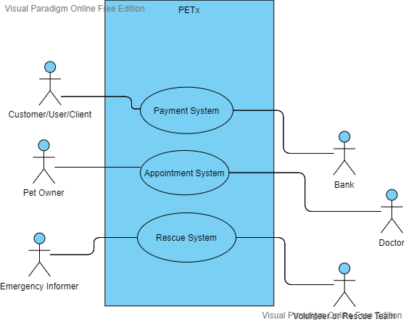

### Analysis Level

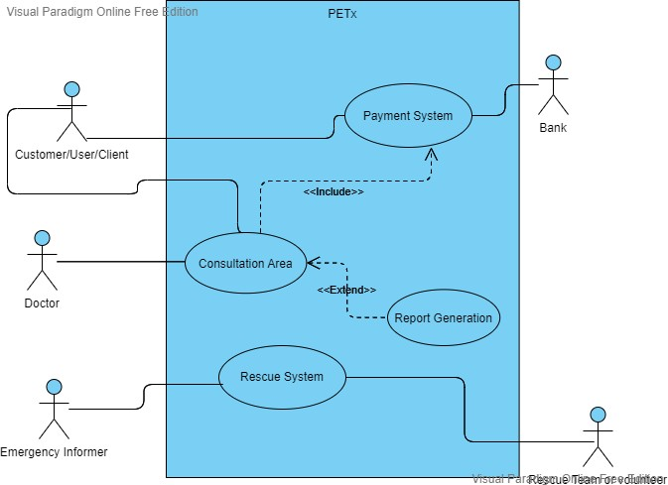

**Faculty of Computing & Information Technology**



Title: **PETx** Deliverable Two

|  |  |  |
| --- | --- | --- |
| **Sr #.** | **Roll Number** | **Student Name** |
| 1 | BSEF19M031 | Ata Ul Mohsin |
| 2 | **BSEF19M033** | **Hassan Ahmad Sarfraz (Lead)** |
| 3 | BSEF19M037 | Muhammad Saad |
| 4 | BSEF19M047 | Muhammad Saleh Butt |

Course Name: Final Year Project

Project Supervisor: Ma’am Natalia Chaudhry Date of Submission:

Dec 26, 2022

Table of Contents

**Table of Contents****2**

**Individual Use Cases****3**

Vet Doctor 3

Rescue Team 3

Pets Community 4

**Use Case Diagrams****5**

Business Level Use Case Diagram 5

Analysis Level Use Case Diagram 7

**Descriptive Use Cases****7**

**Domain Model****13**

**Sequence Diagram****14**

System Sequence Diagrams 16

**Operation / Use Case Contracts****17**

Contract 01: Card verification (Credit / Debit) 17

Contract 02: Courier delivery 18

Contract 03: Appointment System 18

Contract 04: Blogging System 18

Contract 05: Crypto Payments 18

**Design Class Diagram****19**

**Collaboration Diagram****21**

Individual Use Cases

Vet Doctor

**Goal:** Patient pet owner logs into the system and fills out a form for an appointment and selects a schedule as well. Then he pays for appointments via credit card and checks out or exits the system.

A veterinary doctor on the hand, logs in the system and can see a list of his scheduled appointments. He has the right to accept or reject the appointment or he can update the schedule of the appointment.

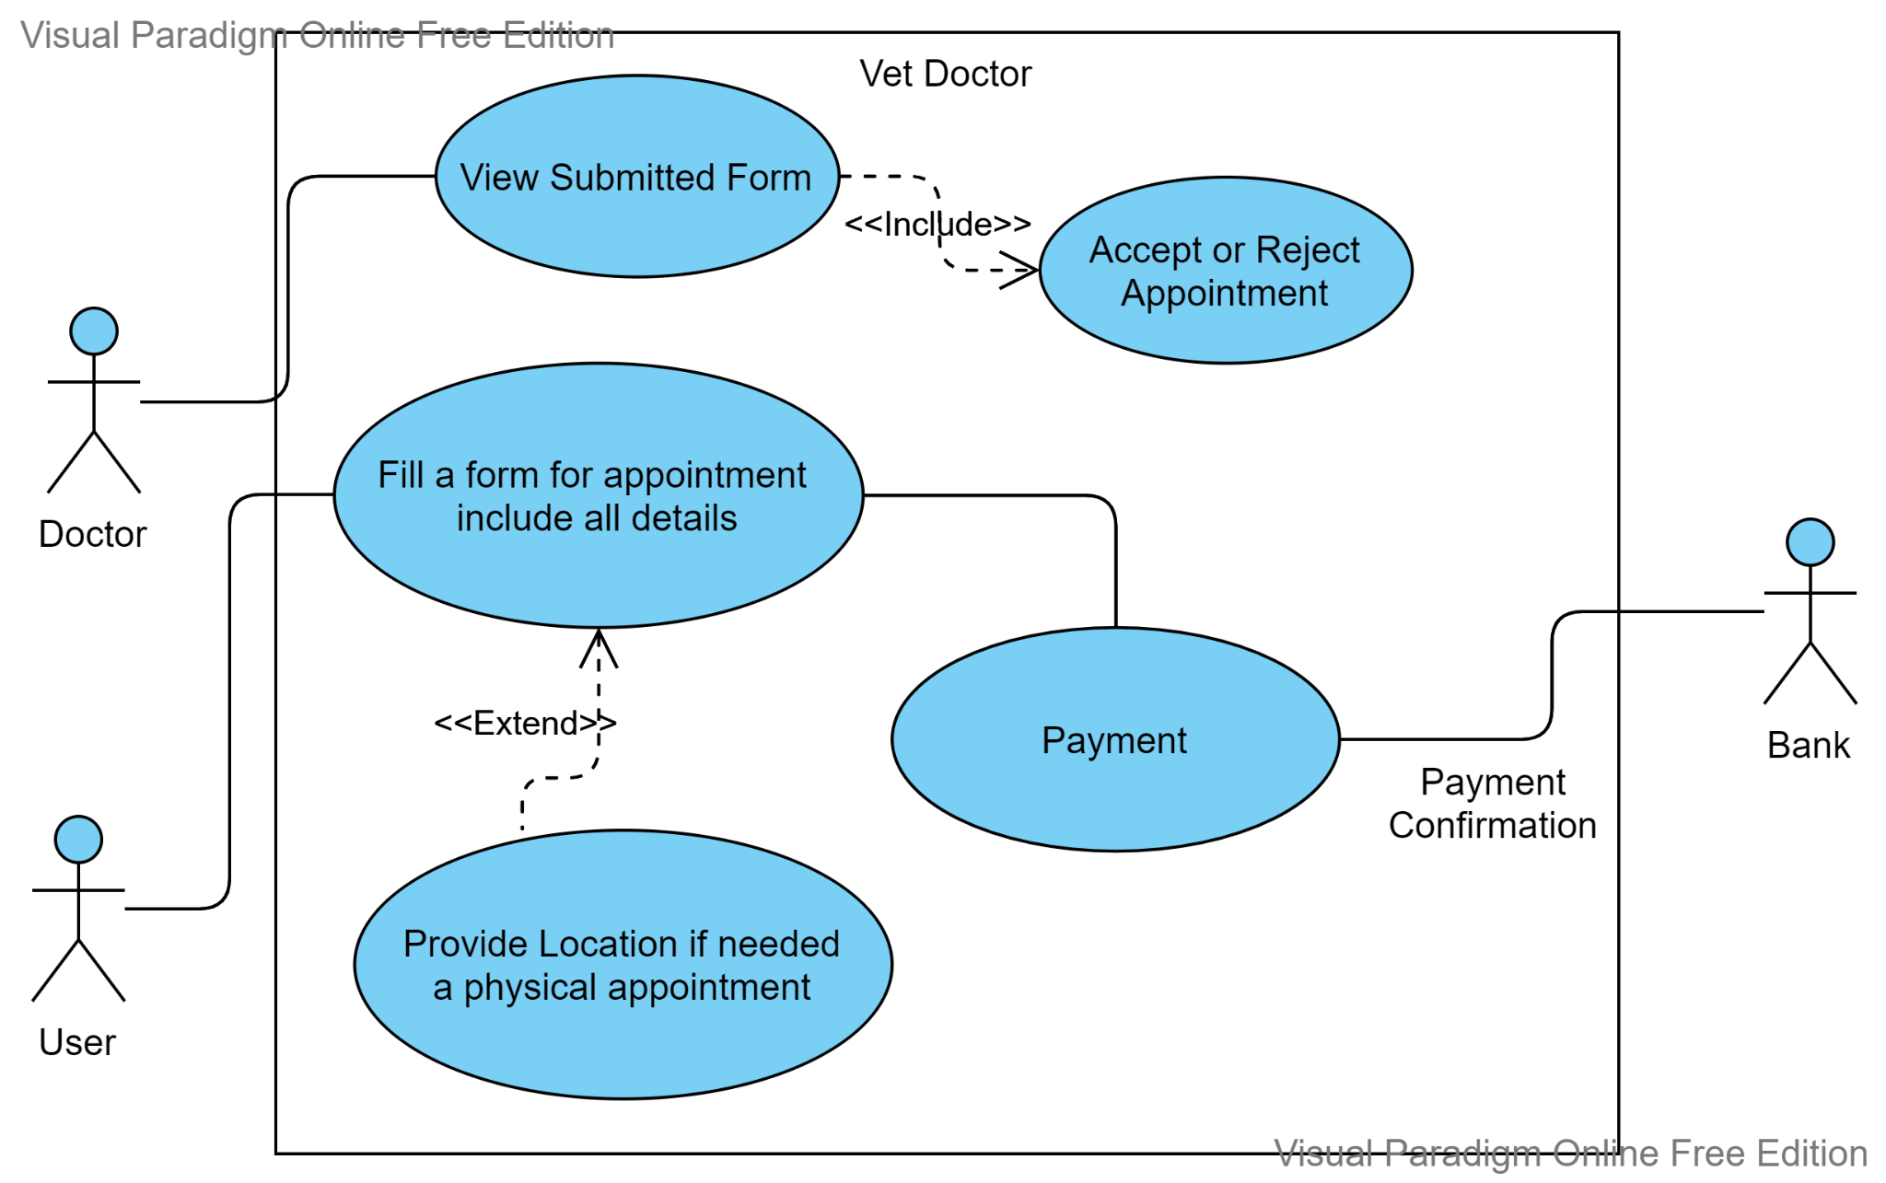

Rescue Team

**Goals:** Any person who can be a user or reporter, reports an incident of a pet emergency and rescue team can view that in the system. If rescue teams can assist online, they do so. If online help is not possible, he can access the location of the emergency incident and visit the place for help.

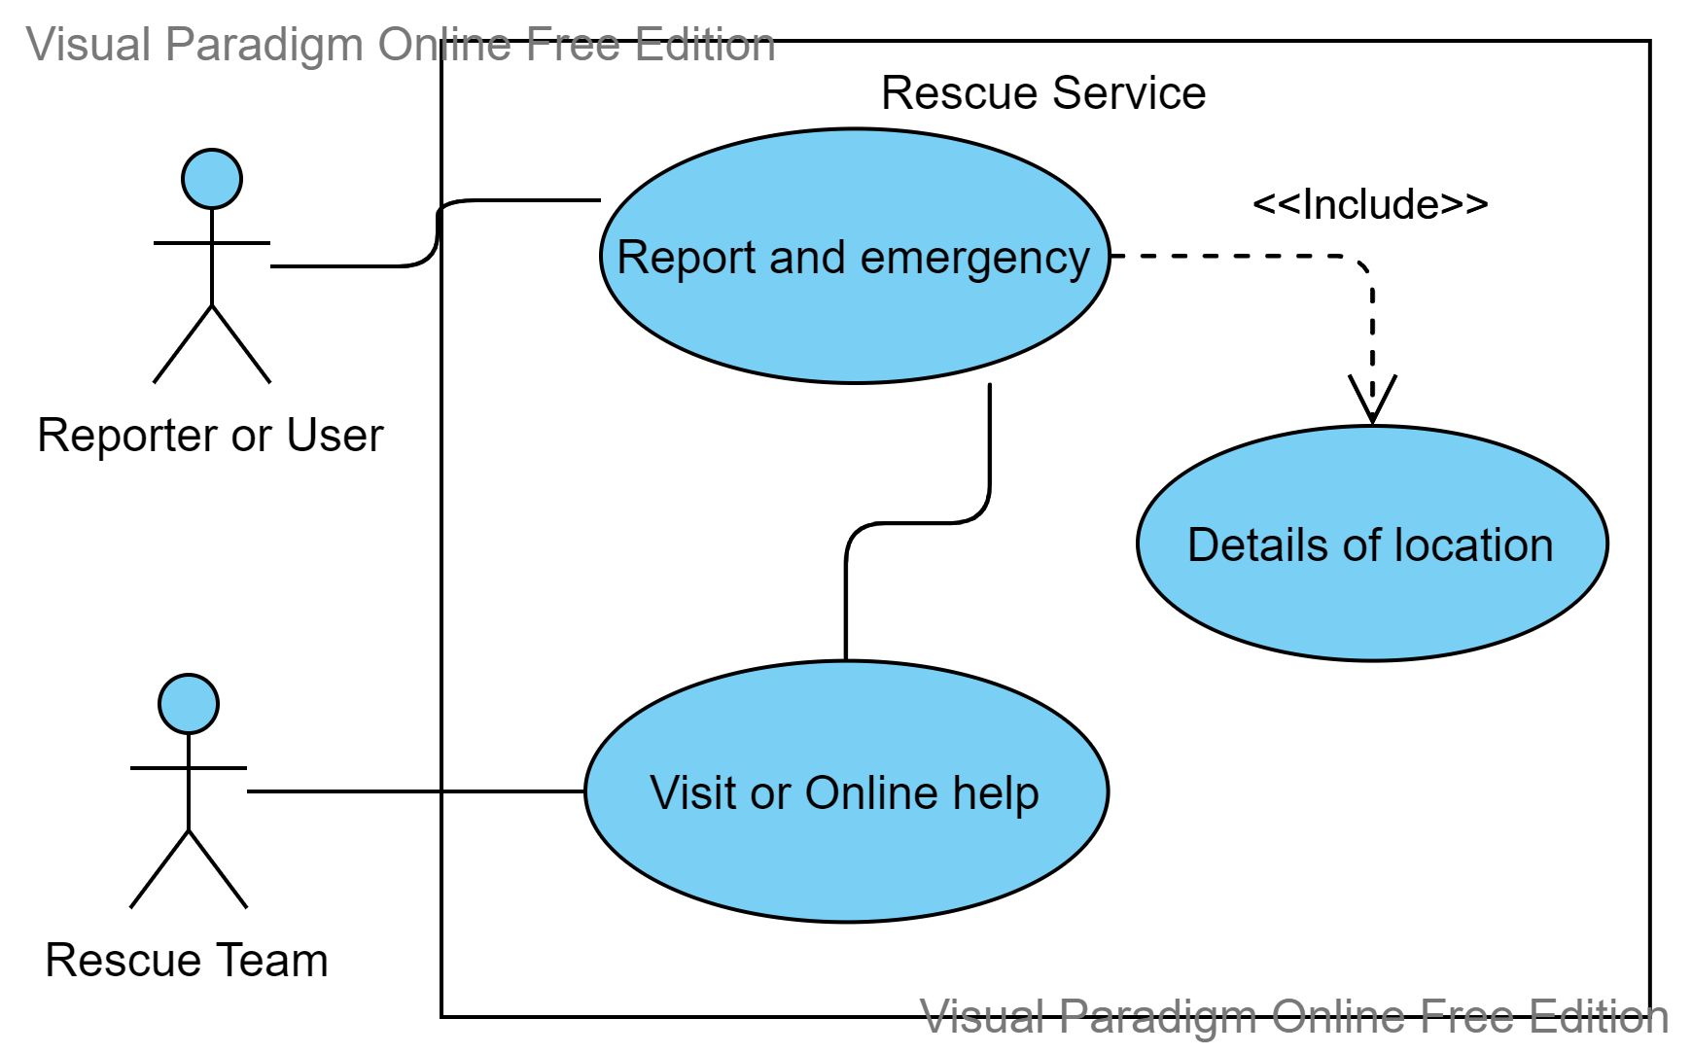

Pets Community

**Goals:** It is a place for social hang outs online. You may call it a blog for pet owners.

Here the pet owner can browse the feed where he can react or comment on the posts of others. He can also post for others.

There’ll be a dedicated area in this blog for common questions for new pet owners where a new pet owner can browse Frequently asked questions for his newly adopted pet.

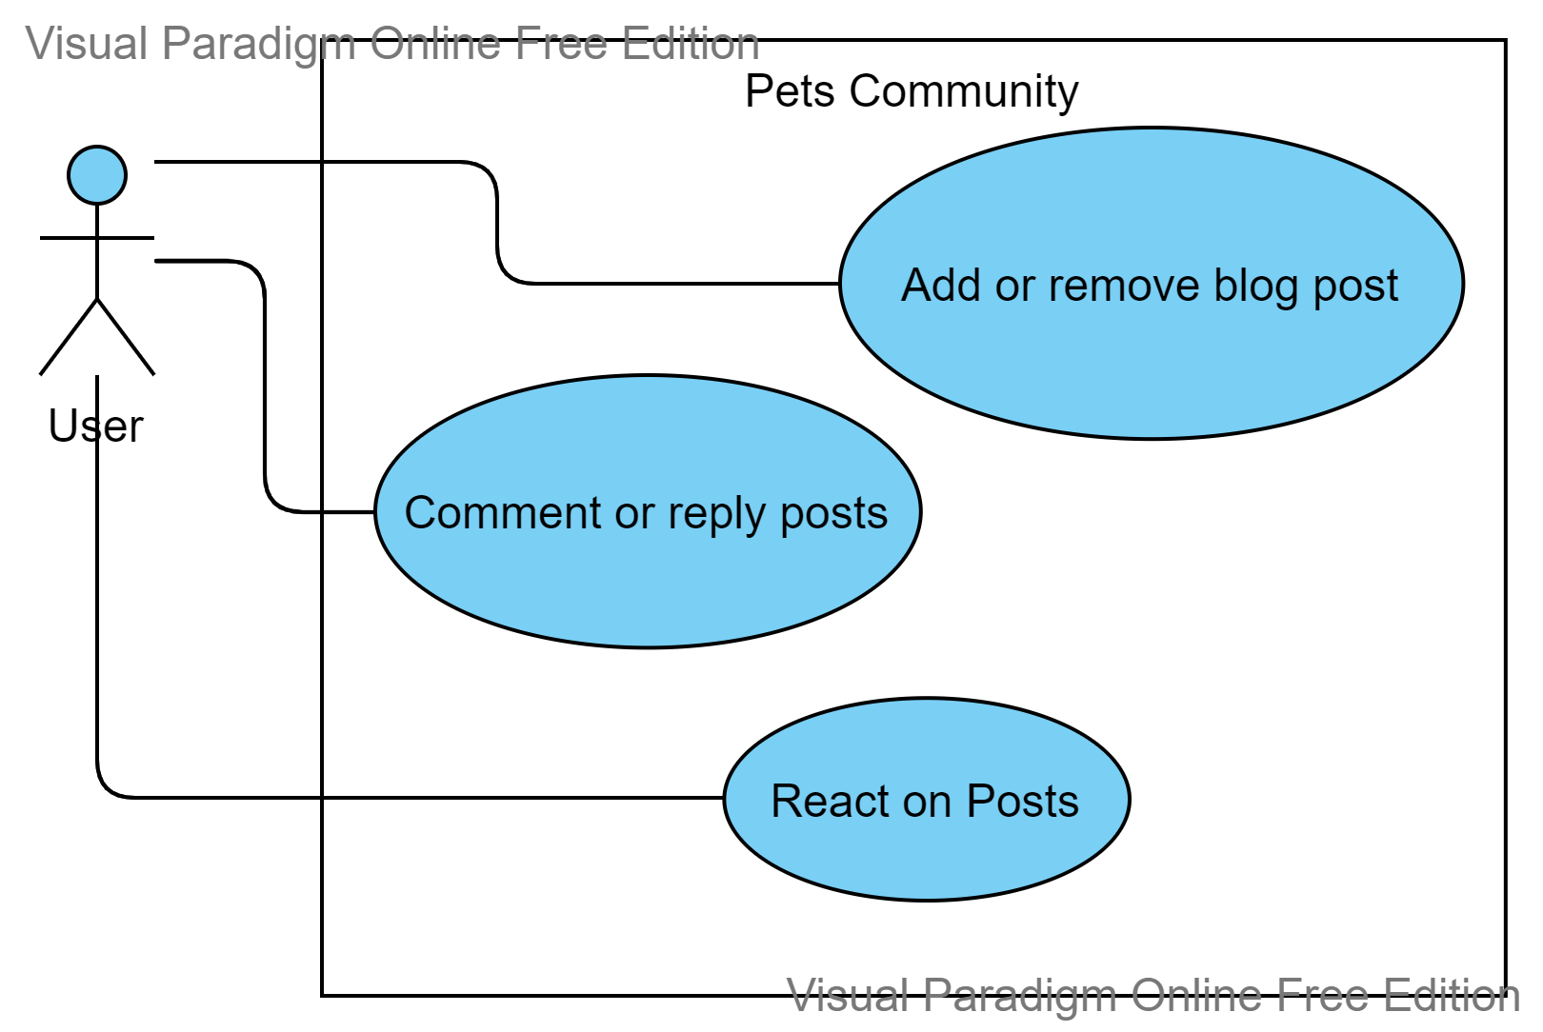

Use Case Diagrams

Business Level Use Case Diagram

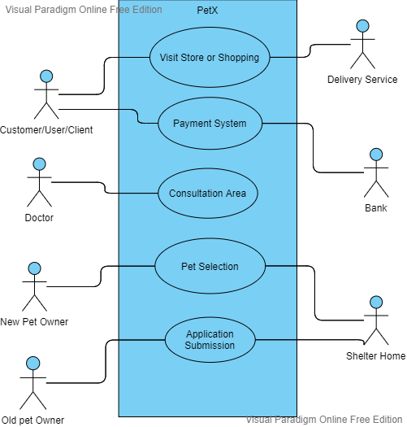

Analysis Level Use Case Diagram

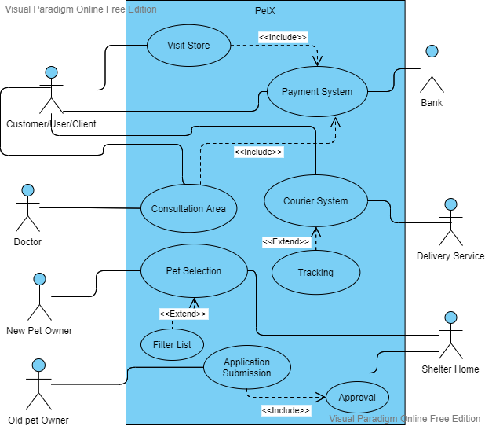

Descriptive Use Cases

|  |  |  |  |  |  |  |
| --- | --- | --- | --- | --- | --- | --- |
|  |  |  |  |  |  |  |
|  | ***Sign Up*** | | | | |  |
|  | ***Description*** | Users provide credentials to create their new account. | | | |  |
|  | ***Actors*** | User | | | |  |
|  | ***Pre***  ***Condition*** | isSignedUp: False | | | |  |

|  |  |  |  |  |  |  |
| --- | --- | --- | --- | --- | --- | --- |
|  | ***Post***  ***Condition*** | New user account will be created. isSignedUp: True | | | |  |
|  | ***Primary Flow*** | ***#*** | ***Actor*** | ***#*** | ***System*** |  |
|  | 1 | Enters Username and  Password | 1 | Check if Username is unique [1(a)] or Not [1(b)]. |  |
|  | 2 | Account accessed | 1(a) | Account created with unique  Username |  |
|  |  |  |  |  |  |
|  | ***Alternate Flow*** | ***#*** | ***Actor*** | ***#*** | ***System*** |  |
|  | 1 | Re-Enters the Username and  Password | 1(b) | Username already found, takes input again. |  |
|  |  |  |  |  |  |
|  |  |  |  |  |  |  |
|  |  |  |  |  |  |  |
|  | ***Login*** | | | | |  |
|  | ***Description*** | User provides credentials to access their already created account. | | | |  |
|  | ***Actors*** | User. | | | |  |
|  | ***Pre***  ***Condition*** | isSignedUp: Ture, isLoggedIn: False | | | |  |
|  | ***Post***  ***Condition*** | isLoggedIn: True | | | |  |
|  | ***Primary Flow*** | ***#*** | ***Actor*** | ***#*** | ***System*** |  |
|  | 1 | Enters Username and  Password | 1 | Check if Record is matched [1(a)] or Not [1(b)]. |  |
|  | 2 | Account accessed | 1(a) | Account accessed |  |
|  |  |  |  |  |  |
|  | ***Alternate Flow*** | ***#*** | ***Actor*** | ***#*** | ***System*** |  |
|  | 1 | Re-Enters the Username and  Password | 1(b) | Match not found, takes input again. |  |
|  |  |  |  |  |  |
|  |  |  |  |  |  |  |
|  |  |  |  |  |  |  |
|  | ***Report Emergency*** | | | | |  |
|  | ***Description*** | Users report some emergency situation to get help for some animal or  pet. | | | |  |

|  |  |  |  |  |  |  |
| --- | --- | --- | --- | --- | --- | --- |
|  | ***Actors*** | User, Rescue Team | | | |  |
|  | ***Pre***  ***Condition*** | isSent: False | | | |  |
|  | ***Post***  ***Condition*** | caseDescription: Not Null, pinLoc: Not Null, isSent: True, isTeamNotified: True, caseID: Not Null. | | | |  |
|  | ***Primary Flow*** | ***#*** | ***Actor*** | ***#*** | ***System*** |  |
|  | 1 | User clicks the SOS button. | 1 | Emergency Form Form will be  shown to the user. |  |
|  | 2 | Describes the case in a form. | 2 | Highlight the input field for  description. |  |
|  | 3 | Adds location. | 3 | Ask for location |  |
|  | 4 | Submit Report. | 4 | Check if input fields are empty  [1(a)] or not [5]. |  |
|  |  |  | 5 | Send the report to the Rescue  Team and notify them. |  |
|  |  |  |  |  |  |
|  | ***Alternate Flow*** | ***#*** | ***Actor*** | ***#*** | ***System*** |  |
|  | 1 | Enter the specified details. | 1(a) | Ask for form resubmission. |  |
|  |  |  |  |  |  |
|  |  |  |  |  |  |  |
|  |  |  |  |  |  |  |
|  | ***Request Appointment*** | | | | |  |
|  | ***Description*** | Users will request some doctor for an appointment. | | | |  |
|  | ***Actors*** | User, Doctor | | | |  |
|  | ***Pre***  ***Condition*** | petHist: Not Null, petDetails: Not Null, isDocAvbl: True, isFeeAgreementSigned: True | | | |  |
|  | ***Post***  ***Condition*** | description: Not Null, isSent: True, approvalStatus: Pending, aptmntDateTime: Null. | | | |  |
|  | ***Primary Flow*** | ***#*** | ***Actor*** | ***#*** | ***System*** |  |
|  | 1 | User provides a case  description on request. | 1 | System provides a form to the user. |  |
|  | 2 | User provides pet medical  history (text / attachments) | 2 | Input areas are highlighted on focus. |  |
|  | 3 | User provides pet details  (breed, age, etc) | 3 | Checks if inputs are empty [1(a)] or not [4] |  |

|  |  |  |  |  |  |  |
| --- | --- | --- | --- | --- | --- | --- |
|  |  | 4 | Request is submitted | 4 | Notify the doctor and wait for  req approval. |  |
|  | 5 | User is notified about the  doctor's response on request. | 5 | User is notified with approval status and date time. |  |
|  |  |  |  |  |  |
|  | ***Alternate Flow*** | ***#*** | ***Actor*** | ***#*** | ***System*** |  |
|  | 1 | Enter the specified details. | 1(a) | Ask for form resubmission. |  |
|  |  |  |  |  |  |
|  |  |  |  |  |  |  |
|  |  |  |  |  |  |  |
|  | ***Read Blogs*** | | | | |  |
|  | ***Description*** | Users can read the blogs published by other users. | | | |  |
|  | ***Actors*** | Users. | | | |  |
|  | ***Pre***  ***Condition*** | isLoggedIn: True, publishedBlogs: >0 | | | |  |
|  | ***Post***  ***Condition*** | Not Required | | | |  |
|  | ***Primary Flow*** | ***#*** | ***Actor*** | ***#*** | ***System*** |  |
|  | 1 | User can scroll through blogs  and read | 1 | System will enlist all the published blogs |  |
|  |  |  |  |  |  |
|  | ***Alternate Flow*** | ***#*** | ***Actor*** | ***#*** | ***System*** |  |
|  | 1 | Error Message. | 1 | Blog not found or is data  unreadable |  |
|  |  |  |  |  |  |
|  |  |  |  |  |  |  |
|  |  |  |  |  |  |  |
|  | ***Write Blogs*** | | | | |  |
|  | ***Description*** | Users can write a blog and publish it. | | | |  |
|  | ***Actors*** | User. | | | |  |
|  | ***Pre***  ***Condition*** | isLoggedIn: True, blogStatus: Draft | | | |  |
|  | ***Post***  ***Condition*** | blogStatus: Published | | | |  |

|  |  |  |  |  |  |  |
| --- | --- | --- | --- | --- | --- | --- |
|  | ***Primary Flow*** | ***#*** | ***Actor*** | ***#*** | ***System*** |  |
|  | 1 | User will click the pen icon on  the bottom. | 1 | A form will be displayed. |  |
|  | 2 | Users will write blogs and  may attach pictures as well. | 2 | System will check if input isvalid  [3] or not [1(a)]. |  |
|  | 3 | Redirected to the blog  reading page after publishing. | 3 | Blog is published and all users can read it. |  |
|  |  |  |  |  |  |
|  | ***Alternate Flow*** | ***#*** | ***Actor*** | ***#*** | ***System*** |  |
|  | 1 | Re-enters the specified  details. | 1(a) | Ask for form resubmission. |  |
|  |  |  |  |  |  |
|  |  |  |  |  |  |  |
|  |  |  |  |  |  |  |
|  | ***Verify Card*** | | | | |  |
|  | ***Description*** | User provides the credit / debit card details for payment of the  purchases. | | | |  |
|  | ***Actors*** | User, Bank | | | |  |
|  | ***Pre***  ***Condition*** | isPaymentMethodAdded: False, isCardVerified: False. | | | |  |
|  | ***Post***  ***Condition*** | isPaymentMethodAdded: True, isCardVerified: True. | | | |  |
|  | ***Primary Flow*** | ***#*** | ***Actor*** | ***#*** | ***System*** |  |
|  | 1 | User clicks on the "Add  Payment Method" button. | 1 | User is redirected to the verification form. |  |
|  | 2 | User provides card number,  expiry and CVV | 2 | Checks if inputs are valid [3] or [1(a)] |  |
|  | 3 | User is notified with  verification results. | 3 | Send data to the bank and wait for verification. |  |
|  |  |  | 4 | Verified: Payment method  added, Declined: [1(a)] |  |
|  |  |  |  |  |  |
|  | ***Alternate Flow*** | ***#*** | ***Actor*** | ***#*** | ***System*** |  |
|  | 1 | Re-enters the specified  details. | 1(a) | Ask for form resubmission. |  |

|  |  |  |  |  |  |  |
| --- | --- | --- | --- | --- | --- | --- |
|  |  |  |  |  |  |  |
|  |  |  |  |  |  |  |
|  |  |  |  |  |  |  |
|  | ***Checkout*** | | | | |  |
|  | ***Description*** | User use cards to pay doctor fees and other purchases. | | | |  |
|  | ***Actors*** | User. | | | |  |
|  | ***Pre***  ***Condition*** | isPaymentMethodAdded: True, isCardVerified: True, trasacStatus: inProgress. | | | |  |
|  | ***Post***  ***Condition*** | transacStatus: Completed / Declined. | | | |  |
|  | ***Primary Flow*** | ***#*** | ***Actor*** | ***#*** | ***System*** |  |
|  | 1 | User proceed to pay with the  bill | 1 | Card is checked for Balance |  |
|  | 2 | Purchase completed with  success message. | 2 | Process transaction if bal is avbl, otherwise [1(a)]. |  |
|  |  |  |  |  |  |
|  | ***Alternate Flow*** | ***#*** | ***Actor*** | ***#*** | ***System*** |  |
|  | 1 | User notified with failure  message. | 1 | Redirects to the checkout page. |  |
|  |  |  |  |  |  |
|  |  |  |  |  |  |  |

Domain Model

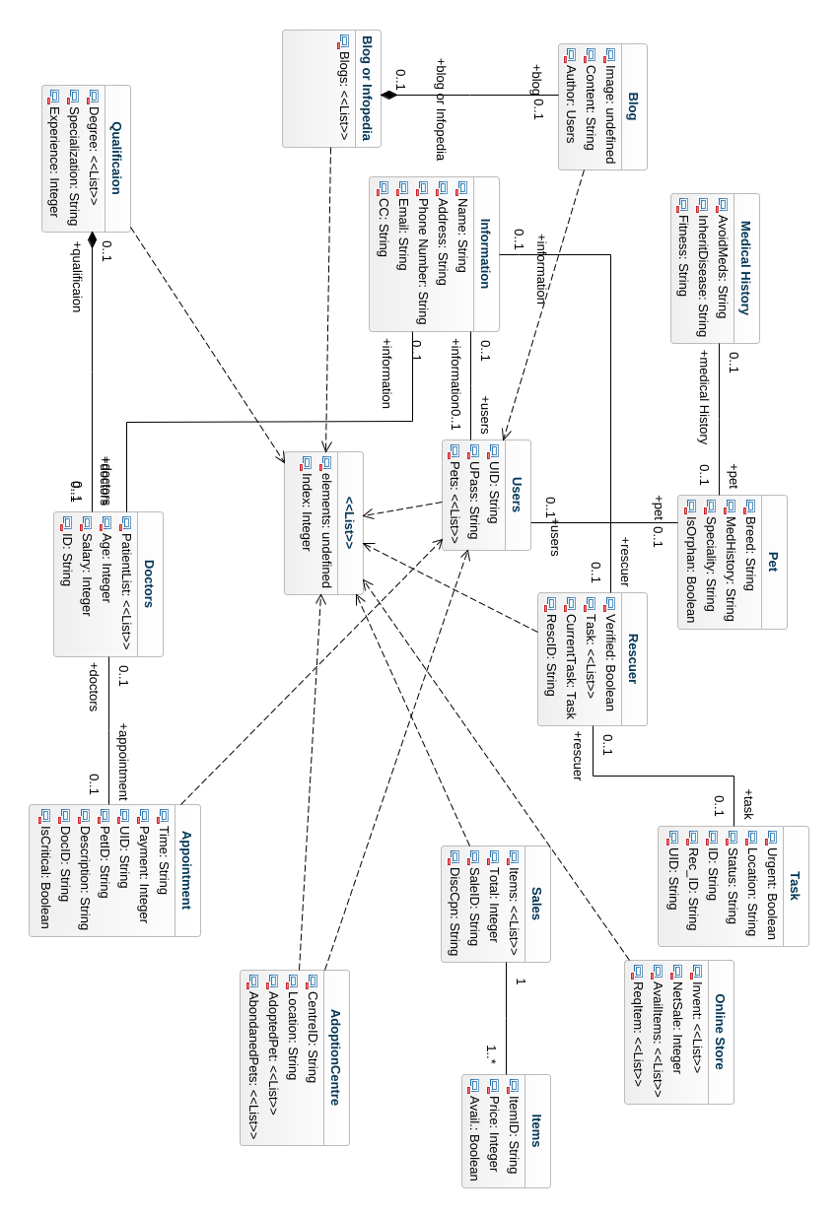

Sequence Diagram

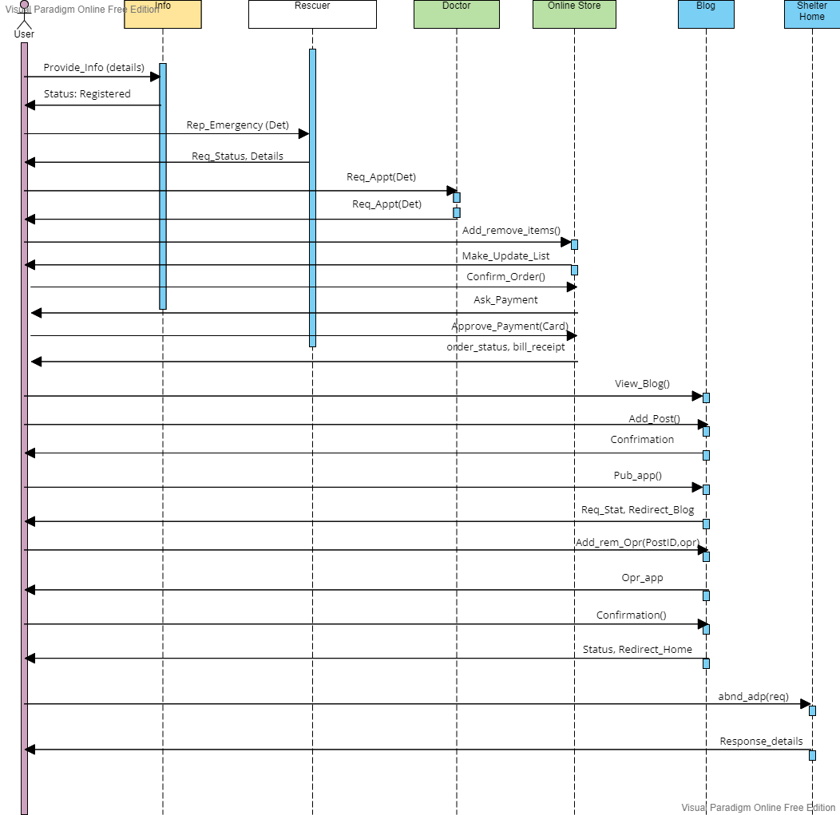

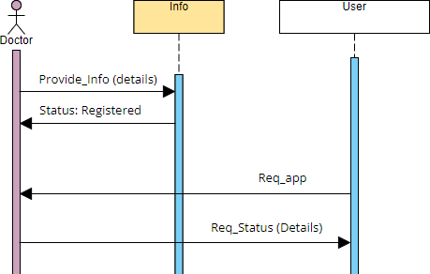

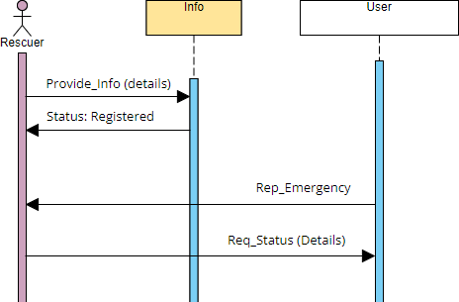

System Sequence Diagrams

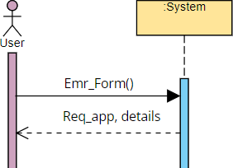

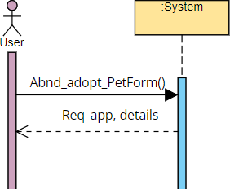

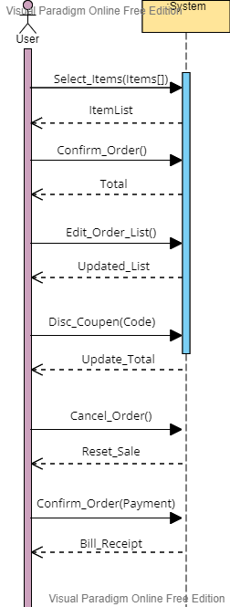

Operation / Use Case Contracts

Contract 01: Card verification (Credit / Debit)

**Operation:** Card verification

**Cross-reference:** Card Verification API

**Pre-Condition:** Payment method: unverified, Checkout Eligibility: false, Service Access: View

Only.

**Post-Condition:** Payment method: verified, Checkout Eligibility: true, Service Access: View and Select.

Contract 02: Courier delivery

**Operation:** Courier delivery

**Cross-reference**: Delivery System

**Pre-Condition:** Cart Item List: Not Null, Payment: Successful, Destination: Not Null, Destination Status: Reachable, Order Id: Not Null and Unique, Tracking ID: Null.

**Pos-Condition:** Tracking ID: Not Null, Wait Time: Not Null, Delivery Status: Delivered / On the way, Cart Item List: Null.

Contract 03: Appointment System

**Operation:** Appointment System

**Cross-reference**: Hospital’s Management System

**Pre-Condition:** Doc availability status: uncertain, Request Status: Pending, Issue Overview: Not Null, Appointment Date Time: Null, Fee Agreement: Signed.

**Pos-Condition:** Doc availability status: Occupied / Avbl, Request Status: Rejected / Approved, Appointment Date Time: Not Null and Valid.

Contract 04: Blogging System

**Operation:** Blogging System

**Cross-reference**: FBs blogging System

**Pre-Condition:** User added: true, Publishing Access: True, View Access: True, Blog body: Not Null, Blog Picture: Null / Not Null.

**Pos-Condition:** Post Status: Published / Draft, Comments: on / off.

Contract 05: Crypto Payments

**Operation:** Crypto Payments

**Cross-reference**: Distributed Ledger System.

**Pre-Condition:** Wallet Integration: Successful, Amount: >0, Currency: Selected (from the list), Amount Available: Ture, Receiver Address: Not Null and Valid, Payment Network: Selected (ERC20, BSC, etc), Password Verification: Successful.

**Pos-Condition:** Transaction Status: Successful / Failed, Balance updated: True.

Design Class Diagram

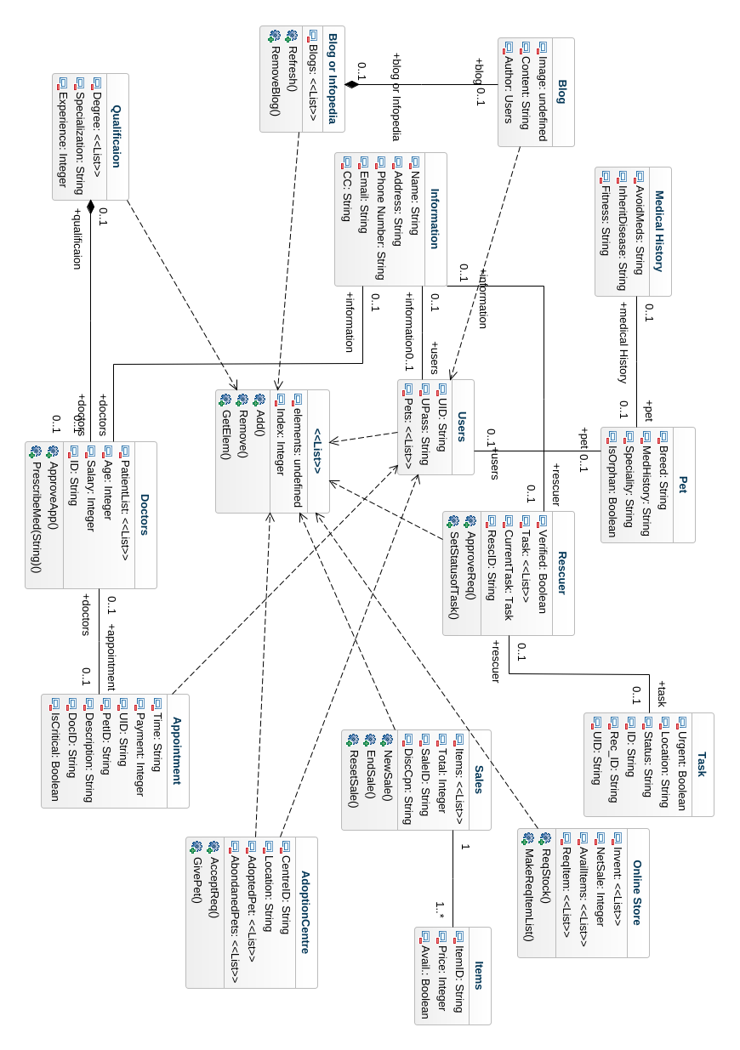

Collaboration Diagram

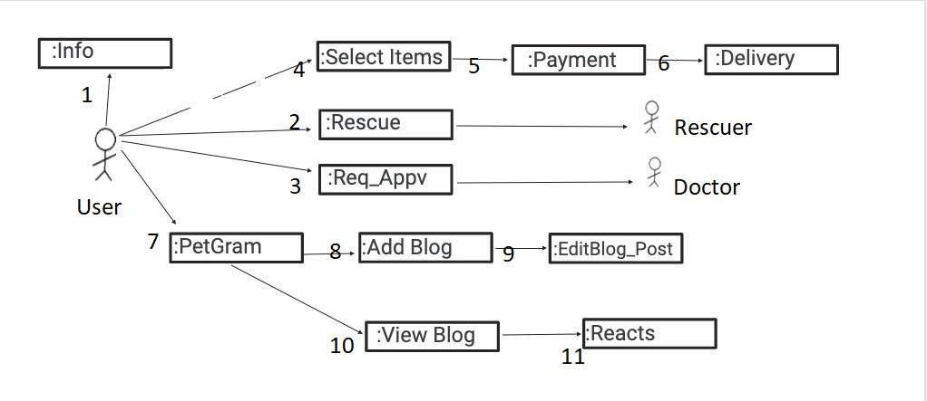

Data Model

